Garnock Community Campus

Leadership Project: Self-Evaluation Planning Template

Step 1: Clarify the Purpose
- What is the change or improvement I want to achieve?
- Who will benefit and how?
- What will be different if this project is successful?

Step 2: Identify Success Criteria
- What does “good” look like for this project?
- What short-term signs of progress should I expect?
- What longer-term outcomes will confirm success?

Step 3: Decide on Evidence Sources
- What existing data can I use? (e.g. attainment, attendance, engagement)
- What new evidence will I collect? (e.g. pupil voice, staff feedback, observations)
- How will I balance numbers (quantitative) with stories/experiences (qualitative)?

Step 4: Plan for Reflection and Next Steps
- When and with whom will I review progress?
- How will I involve others in reflecting on the impact?
- If the evidence suggests limited impact, what will I adjust?

Quick Summary
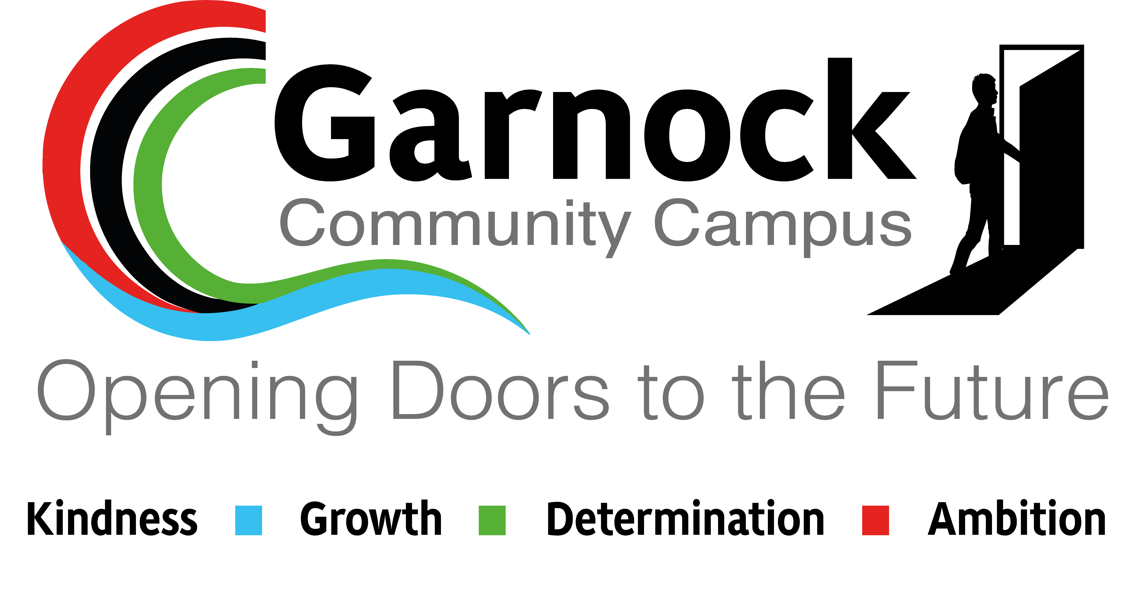
“I will know my project is making a difference when…”

