


Parent Guide
At Garnock Community Campus Early Years (EY) we use Learning Journals to record significant learning of children. For you, this means you can log in to your profile and see these events and comment and contribute. You can access your child’s profile using the website or through the Parent app. If you would like to access via an EY device at any time, just let us know.

On the web
Garnock.yourlearningjournals.co.uk
After you return the permission letter you will be emailed your login details. You will be asked to set a password and PIN.
Using the Parent App
The app is free to download from the Apple Appstore or Google Play Store (search Learning Journals for Parents). You will need to login through the website first (Garnock.yourlearningjournals.co.uk), this is how you set your security details. Once you have done this you can then access your account on the app using those same login details.
The parent app has a basic interface to allow you to do the following:
- View observations and stories for any linked children
- Add in parent contributions
- View Daily Diaries
- View and acknowledge accident / incident forms
- Receive messages
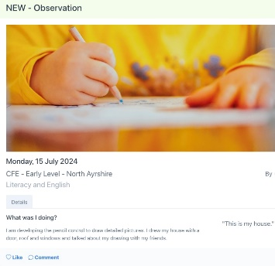
Observations
These are records of significant learning linked to curriculums and frameworks and your child’s individual targets. These are what staff use to evidence progress and development and share your child’s learning with you. You can click on the Learning Outcomes tab of each observation to see which outcomes have been experienced in the observation.

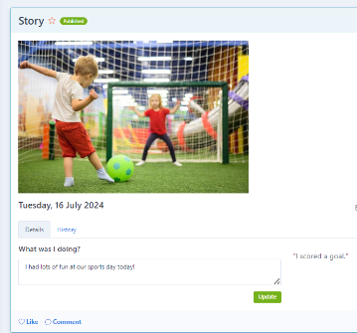
Stories
Stories allow staff to quickly share a nice moment – it might be a fun day, a birthday party, sports day or some other even or activity that you’d love to hear about – without linking it to curriculum frameworks.
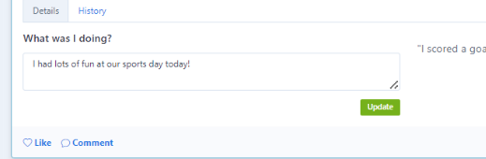
Likes and Comments
Liking and commenting on a post allows staff to know you have seen it and creates a dialogue between home and EY.
Simply click on the ‘like’ button to acknowledge that you’ve seen an update or, even better, leave a comment to let us know how seeing the observation made you feel or what your child has told you about it at home.
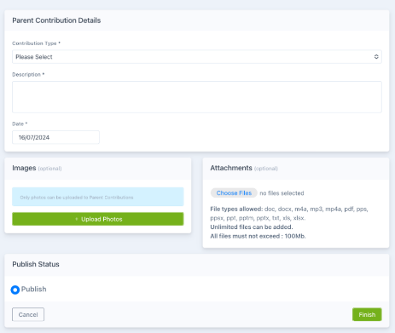
Parent Contributions
We love parent contributions! To share news from home all you need to do is click on the +Add Parent Contribution button on the website or +New Contribution in the parent app. You can then add in details of your home event and attach photos (we’re afraid that videos cannot be uploaded by parents at the moment)
You might want to add something about your child’s new interests, a day trip or an achievement like a swimming award or learning to ride a bike. These help staff to support your child’s learning and celebrate their successes.
Messages and Accident Forms
At Garnock EY we often use Learning Journals as a means of communicating with families about centre news and events. Messages will be sent to your registered email address and can also be accessed via the in-box on the Learning Journals website and app.

Exporting and saving your profile
When it comes time for you to move on you can export everything that has ever been uploaded. This means all your observations, stories, parent contributions, photos and videos. Just click on the Profile to PDF button. You’ll then be able to select from some options of what you want to include. The system will then create a PDF for you which will become available from the Your Downloads tab. This is yours to save or print as required, however please remember photographs containing other children cannot be shared publicly.
Please note, this feature cannot be performed using the Parent App and must be done via the website Garnock.yourlearningjournals.co.uk
Logon Details
If you forget your password or PIN please click on the Forgot your Password? Link on the website or app or Carol Davidson (SEYP) or Erin Carmichael (EYM) who will resend your details.

